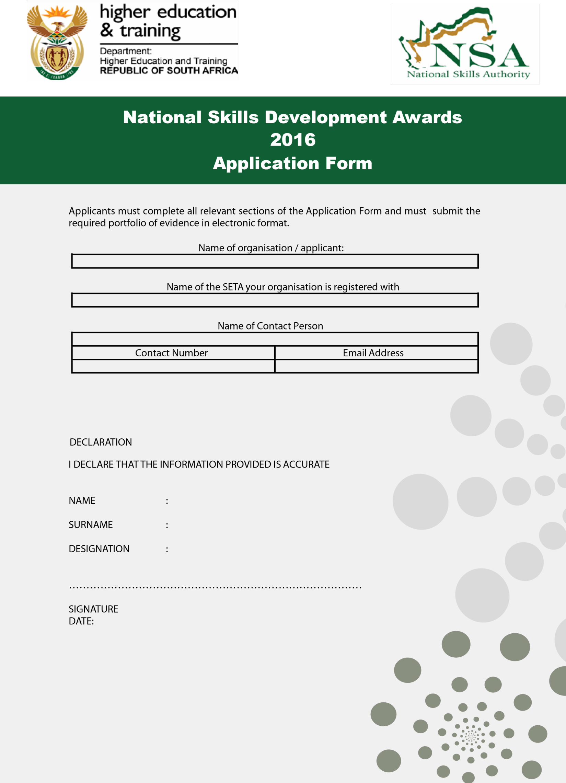
sdfsd
National Skills Development Awards
2019
Application Form

Categories 1 - 22 |  | Mark with X | Criteria (2017/2018  performance)
Best Artisan Development Programme
Provincial Department |  |  | The submission should provide information on:  - Number of artisans trained and qualified.  - Number of artisans employed (both 18:1 and 18:2 learners as per the SDA)  - Employment Equity alignment (Gender, Race, disability)
National Department
Municipality
Large company
Small (SMME) Company
State owned Entity (SoE)
Best TVET placement programme
TVET College / Employer & Provider |  |  | - Partnership between TVET/Employer  - Number of TVET college students placed (both 18:1 and 18:2 learners as per the SDA)  - Employment Equity alignment (Gender, Race, disability)
Best Adult Education and Training (AET) Programme
Employer & Provider |  |  | - Number of learners trained through AET( both 18:1 and 18:2 learners as per the SDA)  - Employment Equity alignment (Gender, Race, disability)
Best Skills Programme
Provincial Department |  |  | - Number of learners trained through skills programme (intake and succession) both 8:1 and 18:2 learners as per the SDA)  - Employment Equity alignment (Gender, Race, disability)
National Department
Municipality
SMME Company
Large Company
SoE
Best University Programme (WIL) | Placement

University & Employer |  | - Partnership between University Employer Number of graduates placed  - Number of graduates employed  - Employment Equity alignment (Gender, Race, disability)
Best Community project
NGO/CBO/NPO/worker initiated programme/cooperative |  | - Number of beneficiaries employed  - Employment Equity alignment (Gender, Race, disability)
Best Public Sector Internship and
learnership programmes
National Department |  | - Number of interns, and learners appointed into the post establishment.  - 5% target (recruitment) achieved against total staff compliment.  - Employment and equity alignment (gender and race and 2% disability target).
Provincial Department
Municipality
Best career and vocational guidance
programme
Career guidance partnership |  | - Partnerships and working relationships with other similar organisations and departments  - Innovation and multiple platforms for accessing services  - Career information for citizens in disadvantaged and/or rural areas

NATIONAL SKILLS DEVELOPMENT AWARDS

Artisan Development Programmes offered between 1 April 2017 and 31 March 2018

Name of Registered Apprenticeship Trade | Number of Learners Registered |  | Number of Learners Certificated |  | Number of Learners placed in  permanent employment | Employment Equity alignment (Race, gender and disability) * Provide an indication of how many learners were registered,  certificated and placed per equity
 | Employed | Unemployed | Unemployed | Unemployed | Unemployed

Learner Profile |  |  |  |  |  |  | People with disabilities
 | Number of Learners  Registered |  | Number of Learners Certificated |  | Number of Learners placed in work  integrated |  | Number of Learners  Registered |  | employment Number of Learners  Certificated |  | Number of Learners placed in work integrated learning opportunities  /employment
 |  |  |  |  | learning
opportunities /
employment
 | Male | Female | Male | Female | Male | Female | Male | Female | Male | Female | Male | Female
African
Coloured
Indian
White

Please attach a one page case study demonstrating the implementation of best practice in skills development as it relates to the provision of artisan development programmes in your organisation.

TVET placement programmes offered between 1 April 2017 and 31 March 2018

Name of Programme | Name TVET/SETA/Employer | of | Number of Learners Registered |  | Number of Learners placed in permanent employment | Employment Equity alignment (Race, gender and disability)  * Provide an indication of how many learners were registered, certificated  and placed per equity
 |  |  | Employed | Unemployed | Unemployed

Learner Profile |  |  |  |  |  |  | People with disabilities
 | Number of Learners  Registered |  | Number of Learners Certificated |  | Number of Learners placed in work  integrated |  | Number of Learners  Registered |  | employment Number of Learners Certificated |  | Number of Learners placed in work integrated learning opportunities  /employment
 |  |  |  |  | learning
 |  |  |  |  | opportunities / employment
 | Male | Female | Male | Female | Male | Female | Male | Female | Male | Female | Male | Female
African
Coloured
Indian
White

Please attach a one page case study demonstrating the implementation of best practice in skills development as it relates to the provision of placement programmes in your organisation.

AET Programmes offered between 1 April 2017 and 31 March 2018

Name of Programme | Name of SETA/Employer | Number of Learners Registered |  | Employment Equity alignment (Race, gender and disability)  * Provide an indication of how many learners were registered, certificated and placed per equity
 |  | Employed | Unemployed

Learner Profile |  |  |  |  |  |  | People with disabilities
 | Number of Learners  Registered |  | Number of Learners Certificated |  | Number of Learners placed in work  integrated |  | Number of Learners  Registered |  | employment Number of Learners Certificated |  | Number of Learners placed in work integrated learning opportunities  /employment
 |  |  |  |  | learning
 |  |  |  |  | opportunities / employment
 | Male | Female | Male | Female | Male | Female | Male | Female | Male | Female | Male | Female
African
Coloured
Indian
White
Please attach a one page case study demonstrating the implementation of best practice in skills development as it relates to the provision of AET programmes in your organisation.

Skills Programmes offered between 1 April 2017 and 31 March 2018
Name of Programme | Name of Organisation / Employer | Number of Learners Registered |  | Employment Equity alignment (Race, gender and disability)  * Provide an indication of how many learners were registered, certificated and placed per  equity
 |  | Employed | Unemployed

Learner Profile |  |  |  |  |  |  | People with disabilities
 | Number of Learners  Registered |  | Number of Learners Certificated |  | Number of Learners placed in work  integrated |  | Number of Learners  Registered |  | employment Number of Learners Certificated |  | Number of Learners placed in work integrated learning opportunities  /employment
 |  |  |  |  | learning
 |  |  |  |  | opportunities / employment
 | Male | Female | Male | Female | Male | Female | Male | Female | Male | Female | Male | Female
African
Coloured
Indian
White

Please attach a one page case study demonstrating the implementation of best practice in skills development as it relates to the provision of skills programmes in your organisation.

University Placement Programme (WIL) offered between 1 April 2017 and 31 March 2018
Name of Programme | Name of University/ Employer | Number of Learners Registered |  | Number of Learners placed in permanent employment | Employment Equity alignment (Race, gender and disability) * Provide an indication of how  many learners  were registered, certificated and placed per equity
 |  | Employed | Unemployed | Unemployed

Learner Profile |  |  |  |  |  |  | People with disabilities
 | Number of Learners  Registered |  | Number of Learners Certificated |  | Number of Learners placed in work  integrated |  | Number of Learners  Registered |  | employment Number of Learners Certificated |  | Number of Learners placed in work integrated learning opportunities  /employment
 |  |  |  |  | learning
 |  |  |  |  | opportunities / employment
 | Male | Female | Male | Female | Male | Female | Male | Female | Male | Female | Male | Female
African
Coloured
Indian
White

Please attach a one page case study demonstrating the implementation of best practice in skills development as it relates to the provision of learnership training

Best Community Project 2017 and 31 March 2018
Name of Programme | Name of Organisation/Employer | Number of Learners Registered |  | Number of Learners placed in permanent employment | Employment Equity alignment (Race, gender and disability) * Provide an indication of how  many learners  were registered, certificated and placed per equity
 |  | Employed | Unemployed

Learner Profile |  |  |  |  |  |  |  | People with disabilities
Number of Learners  Registered |  | Number of Learners Certificated |  | Number of Learners placed in work  integrated learning  opportunities  / employment |  | Number of Learners  Registered |  |  | 8employment Number of  Learners Certificated |  | Number of Learners placed in work integrated learning opportunities  /employment
Male | Female | Male | Female | Male | Female | Male | Female |  | Male | Female | Male | Female
African
Coloured
Indian
White

Please attach a one page case study demonstrating the implementation of best practice in skills development as it relates to the provision of skills programmes in your organisation.

Best Public Sector Internship and learnership programmes offered between 1 April 2017 and 31 March 2018
Name of Programme | Name of Employer | Number of Learners Registered |  | Number of Learners Completed |  | Number of Learners placed in  permanent employment | 5% target (recruitment) achieved  against  total staff compliment. | Employment Equity alignment  (Race,  gender and disability)
 |  | Employed | Unemployed | Employed | Unemployed | Unemployed

Learner Profile |  |  |  |  |  |  |  | People with disabilities
Number of Learners  Registered |  | Number of Learners Certificated |  | Number of Learners placed in employment |  | Number of Learners  Registered |  | employment Number of Learners Certificated |  | Number of Learners placed in employment
Male | Female | Male | Female | Male | Female | Male | Female | Male | Female | Male | Female
African
Coloured
Indian
White

Please attach a one page case study demonstrating the implementation of best practice in skills development as it relates to the provision of internship and learnership opportunities in your organisation.

NATIONAL SKILLS DEVELOPMENT AWARDS
Career guidance programmes offered between 1 April 2017 and 31 March 2018
Name of Programme | Name of Employer & Partner | Number of Learners Registered |  | Platforms for accessing services | 5% target (recruitment) achieved against total staff compliment. | Employment Equity alignment (Race, gender and  disability)
 |  | Unemployed | Employed |  | Unemployed

Learner Profile |  |  |  |  |  |  | People with disabilities
 | Number of Learners  Registered |  | Number of  Learners Certificated |  | Number of Learners placed in work |  | Number of Learners  Registered |  | employment Number of  Learners |  | Rural coverage Name of Province
 |  |  |  |  | integrated learning |  |  |  | Certificated
 |  |  |  |  | opportunities
 |  |  |  |  | / employment
 | Male | Female | Male | Female | Male | Female | Male | Female | Male | Female | Male | Female
African
Coloured
Indian
White
Please attach a one page case study demonstrating the implementation of best practice in skills development as it relates to the provision of internship and learnership opportunities in your organisation.

CATEGORY 23 - NSA CHAIRPERSON’S AWARD FOR RECOGNITION OF MOST OUTSTANDING SETA)
(indicate with “X” if applying for this category)
NSDSIII GOALS | CRITERIA | RECIPIENT
Goal 4.2 Increasing access to occupationally‐directed programmes  Goal 4.3 Promoting the growth of a public FET College system that is responsive to sector, local, regional and national skills needs and priorities  Goal 4.4 Addressing the low level of youth and adult language and numeracy skills to enable additional training  Goal 4.5. Encouraging better use of workplace-based skills development  Goal 4.6. Encouraging and supporting cooperatives, small enterprises, worker-initiated, NGO and community training initiatives  Goal 4.7 Increasing public Sector capacity for improved service delivery and supporting the building of a developmental state  Goal 4.8 Building career and vocational guidance | 1. PERFORMANCE AGAINST TARGETS  The submission should provide information on:  Service Level Agreement.  Annual Performance Plan.  Annual budget achievement.  Overall organisational performance. | Best SETA
2. GOVERNANCE
The submission should provide information on:
Board composition as per the SDA.
Number of board meetings held.
Board member attendance.
3. FINANCIAL SUSTAINABILITY
The submission should provide information on:
Financial position including commitments, reserves, assets and liabilities.
Auditor-General report including whether or not irregular expenditure was incurred.
4. MANAGEMENT / CORPORATE SERVICES
The submission should provide information on:
Number of vacancies and filled positions.
Organisation structure / organogram to be provided, including equity profile.
Employment and equity alignment (race, gender and disability)
5. COLLABORATION / PARTNERSHIPS
The submission should provide information on:
Stakeholder relations and number of partnership initiatives.
6. INNOVATION / CREATIVITY
The submission should provide information on:
Innovative / creative ideas E.g. for overcoming challenges such as meeting/exceeding targets despite limited funding.
7. ACCESSIBILITY OF INFORMATION
The submission should provide information on:
User-friendliness for learners, stakeholder and/or beneficiaries E.g creation of portals for students.

PERFORMANCE AGAINST TARGETS BETWEEN 1 APRIL 2017 TO 31 MARCH 2018

1. Service Level Agreement Performance
 | Number of Targets Agreed Upon | Number of Targets Not Met | Number of Targets Achieved
Number
Percentage
2. Annual Performance Plan (APP) Achievement
 | Number of Targets Agreed Upon | Number of Targets Not Met | Number of Targets Achieved
Number
Percentage
3. Summary Budget Achieved
 | Annual Budget | Total Actual Expenditure | Percentage of Annual Budget Expended
4. Overall Organisation Performance
Percentage

GOVERNANCE BETWEEN 1 APRIL 2017 TO 31 MARCH 2018

1. Board composition
Board Member |  | Constituency Representation
1.
2.
3.
4.
5.
6.
7.
8.
9.
10.
11.
12.
13.
15.
2. Number of board meetings held:
Number of Meetings Attended By Board Members |  | Percentage of Board Meetings Attended

FINANCIAL SUSTAINABILITY FOR PERIOD OF 1 APRIL 2017 TO 31 MARCH 2018
1. Financial Position: (Financial statements to be attached in support)
Current Assets: |  | Current Liabilities: |  |  | Commitments for next 12 months: |  |  | Mandatory Reserves:
Non-Current Assets: |  | Non-Current Liabilities: |  |  | Commitments beyond 12 months: |  |  | Discretionary Reserves:
Cash and Cash Equivalents: |  | Contingent Liabilities: |  |  |  |  |  | Other Reserves:
2. Auditor-General Report (Report to be attached in support)
Audit Finding: (Please indicate with an “X”)
Clean Audit Opinion | Unqualified Audit Opinion |  | Qualified Audit Opinion |  |  | Adverse Audit Opinion |  |  | Disclaimer Audit Opinion
3. Irregular expenditure incurred: ( Please indicate with an “X”) |  |  |  | YES |  |  | NO
Rand Value of Irregular Expenditure:
Percentage of Irregular Expenditure in relation to Total Actual Expenditure:
* For Qualified / Adverse / Disclaimer Audit Opinions, please attach Management Report

MANAGEMENT / CORPORATE SERVICES FOR PERIOD 1 APRIL 2017 TO 31 MARCH 2018

1. Number of Vacancies (Organisation structure/organogram to be provided)
Level | No. of Employees | Approved Positions | Vacancies | Percentage of Vacancies
Top Management
Senior Management
Professional Qualified
Skilled
Semi-Skilled
Unskilled

2. Employment and Equity Alignment
 | TOP MANAGEMENT |  | SENIOR MANAGEMENT |  | PROFESSIONAL QUALIFIED |  | SKILLED |  | SEMI-SKILLED |  | UNSKILLED
 | MALE | FEMALE | MALE | FEMALE | MALE | FEMALE | MALE | FEMALE | MALE | FEMALE | MALE | FEMALE
African
Coloured
Indian
Whited

COLLABORATION / PARTNERSHIPS FOR PERIOD OF 1 APRIL 2017 TO 31 MARCH 2018

Stakeholder &/or Partnership initiative / project | Description and aim | Impact | Beneficiaries
*Portfolio of evidence to be provided

INNOVATION / CREATIVITY FOR PERIOD OF 1 APRIL 2017 TO 31 MARCH 2018

Innovative / Creative ideas eg. Overcoming challenges such as meeting targets despite limited funding.
*Motivation and portfolio of evidence to be provided

ACCESSIBILITY OF INFORMATION FOR PERIOD OF 1 APRIL 2017 TO 31 MARCH 2018

User-friendliness for learners, stakeholders and/or beneficiaries. Eg. Creation of portals for students.
*Motivation and portfolio of evidence to be provided, including feedback from learners, stakeholder and/or beneficiaries.
CATEGORY 24: MINISTER’S AWARD FOR RECOGNITION OF MOST OUTSTANDING INDIVIDUAL (indicate with “X” if applying for this category)
INDIVIDUAL | CRITERIA | RECIPIENT
To recognise an individual who has distinguished him/herself in their professional, organisation and community within the skills development system. | 1. SKILLS DEVELOPMENT PARTICIPATION  The submission should provide information on:  Demonstrate significant levels of involvement in activities in skills development. (Activities to be specified)  The individual seeks out opportunities to contribute to improving the effectiveness and efficiency of the Skills Development System. | Most Outstanding Individual
2. ACCOMPLISHMENT
The submission should provide information on:
Demonstrate exceptional job performance beyond what is normally performed or expected.
Demonstrate commitment to fostering growth and development of individuals by sharing guidance and professional skills. Eg. Mentoring
3. COMMUNITY INVOLVEMENT
The submission should provide information on:
Demonstrate commitment to community by sharing time and talent in ways that benefit the community or individuals within the community. (Sharing time and talent)
Demonstrate personal commitment to skills development endeavours within the community, outside of their professional obligations. (Commitment to skills development)
Played a lead role in developing community awareness of skills development opportunities and/or career development services. (Skills development awareness)
4. LEADERSHIP
The submission should include information on:
Demonstrates initiative and inspires others to work collaboratively and creatively.
Proven willingness to work flexibly when needed.
Individual finds ways to motivate, utilize and incorporate others to move the NSDSIII vision forward.
5. ETHICS AND INTEGRITY
The submission should provide information on:
The individual understands that their actions, both public and private are reflective of their values.
When faced with ethical issues, the individual challenges themselves and others to act in ways congruent with their personal and shared values. E.g. declaring conflict of interest.
The individual demonstrates the highest level of integrity in all aspects of their lives.

Individual (Motivation and portfolio of evidence to be provided)
1. Skills Development Participation
Identify current and/or previous skills development activities the individual is/was involved in. |  | Details and level of involvement in skills development to be provided.
2. Accomplishments
Describe how the performance of the individual is beyond what is normally performed/expected. |  | Demonstrate how the individual shows commitment to fostering growth and development of individuals.
3. Community Involvement
Describe instances when the individual shared time and talent in ways that benefit the community or individuals within the community. | Describe instances when the individual showed personal commitment to skills development endeavours within the community. |  | Describe instances when the individual played a lead role in the community in developing awareness of skills development opportunities and/or career development services.
4. Leadership
Describe instances when the individual demonstrated initiative and inspired others to work collaboratively and creatively. | Provide a track record of the individuals willingness to work flexibly when needed. |  | Demonstrate how the individual finds ways to motivate, utilize and incorporate others to move the NSDSIII vision forward.
5. Ethics and Integrity
Give a description of the individual’s values, characteristics and describe the way the individual conducts him/herself in public and in private. | Describe instances when the individual was faced with ethical challenges and explain how the individual reacted in the circumstances. |  | Motivate how the individual demonstrates the highest level of integrity in all aspects of their lives and why the individual deserves to receive this award.
*Please attached detailed motivation and portfolio of evidence

